Name: B.Vinayani
Registration Number: 192472179

EXPERIMENT 8
Text Generation using Hugging Face Inference API

AIM
To develop a Python program that uses a Hugging Face model through the Inference API to generate text from user-provided prompts.

PROCEDURE
1. Create a Hugging Face account and generate an access token with Inference permission (Settings > Access Tokens).
2. Install the library using: pip install huggingface_hub
3. Store the token in an environment variable named HF_TOKEN.
4. Choose a hosted instruction-tuned model (for example mistralai/Mistral-7B-Instruct-v0.3) and create an InferenceClient.
5. Accept a prompt from the user and call client.chat_completion() with max_tokens and temperature.
6. Display the generated text, run the program with different prompts and capture a screenshot of the output.

CODE
exp8_huggingface.py
"""Experiment 8 - Text generation using the Hugging Face Inference API."""
import os
import sys

from huggingface_hub import InferenceClient

MODEL = "mistralai/Mistral-7B-Instruct-v0.3" # any hosted chat model can be used

def get_client():
token = os.getenv("HF_TOKEN")
if not token:
sys.exit("Error: set the HF_TOKEN environment variable first.")
return InferenceClient(model=MODEL, token=token)

def generate_text(client, prompt, max_tokens=200, temperature=0.7):
"""Generate text for the prompt using the hosted Hugging Face model."""
result = client.chat_completion(
messages=[{"role": "user", "content": prompt}],
max_tokens=max_tokens,
temperature=temperature,
)
return result.choices[0].message.content.strip()

def main():
client = get_client()
print(f"=== Hugging Face Text Generation ({MODEL}) ===")
while True:
prompt = input("\nEnter your prompt (or 'quit' to exit): ").strip()
if prompt.lower() in ("quit", "exit", "q"):
print("Goodbye!")
break
if not prompt:
print("Prompt cannot be empty.")
continue
try:
print("\nGenerating response...")
print("\n--- Generated Text ---")
print(generate_text(client, prompt))
except Exception as err:
print(f"API error: {err}")

if __name__ == "__main__":
main()

OUTPUT
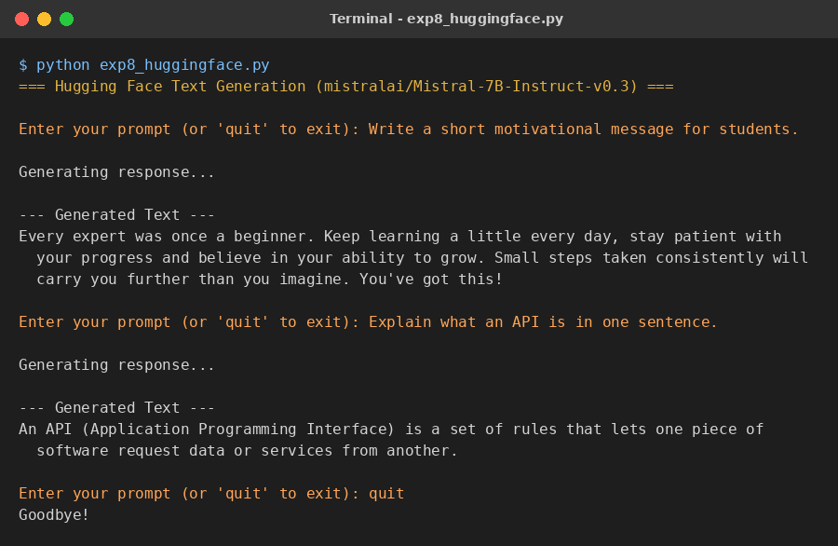
Figure 1: Sample output of the program

RESULT
The Python program sent user prompts to a Hugging Face hosted model through the Inference API and displayed the generated text for each prompt.

CONCLUSION
The Hugging Face Inference API allows open-source models to be used for text generation without local installation or a GPU. Changing the model name is enough to try a different model.

